TEACHING, LEARNING,
ASSESSMENT AND
ACCREDITATION
POLICY



Witham Prospect School
Old Harbour Farm
Newark Road
Norton Disney
LN6 9JR

Policy Lead: Claire Roberts
Review Date: 01/10/2024
Review Due: 01/10/2026

EDUCATION POLICY

Contents
Monitoring and review 4
Availability: 4
Legal framework 4
Related Documents: 5
Applies to: 5
Teaching and Learning 6
Purpose of this Policy 6
Guiding Principles 6
Aims 6
Effective learning for our pupils 7
Effective teaching for our pupils 8
Planning and Preparation Expectations: 9
Teaching Expectations 9
DFE: Summary of Teacher Standards September 2012: 10
Target Setting 11
Key Stage 3 Curriculum 12
Key Stage 4 Curriculum 13
Key Stage 5 Curriculum 14
Implementing our Curriculum 15
Current accreditation options available to all our pupils 15
Transition Planning and Future Opportunities for All 16
Value and purpose of displays 16
Assessment 17
The Purpose of Assessment 17
Rationale for Assessment and Tracking of Progress 17
Effective Assessment requires: 18
Day to Day Assessment: 18
Summative Assessment 21
Keeping our Parents and Carers in the Loop 23
Accreditation 23

Monitoring and review
This policy will be monitored and refined on a continuous basis and reviewed annually by either the Head Teacher, Director of Education or a member of the Senior (education) Leadership Team. This will take place earlier if changes in legislation, regulatory requirement or best practice guidelines so require.

Availability:
This policy is made available to parents/carers, staff and pupils via the School website or upon request from the school office.

Legal framework
Relevant Legislation and Guidance
- The Children’s Homes (England) Regulations 2015 – UK Gov.
- Guide to the Children’s Homes Regulations, including the quality standards April 2015 – DFE.
- Social Care Common Inspection Framework SCCIF: children’s homes (latest version) – OFSTED.
- Positive environments where children can flourish (latest version) – OFSTED.
- The Education (Independent School Standards) Regulations 2014 (latest available, revised) – UK Gov.
- Education Inspection Framework: EIF (latest version) – OFSTED.
- Non – association independent schools inspection handbook (latest version) – OFSTED.
- Keeping Children Safe in Education, statutory guidance for schools and colleges (latest version) – DFE.
- Working Together to Safeguard Children, a guide to multi-agency working to help, protect and promote the welfare of children (revised latest version) – HM Gov.
- Lincolnshire Safeguarding Children Partnership (LSCP): Policy and Procedures – live manual.

Related Documents:
- Subject Policies, including long term planning
- Teaching and Learning Policy
- Assessment and Marking Policy
- Curriculum Policy
- Spiritual, Moral, Social and Cultural (SMSC) Policy

Applies to:
The whole school, staff, volunteers and pupils. All activities provided by the school, including those activities outside the normal school day, off-site learning and residential trips. This policy also applies to residential care, residential staff and volunteers.

Teaching and Learning

Purpose of this Policy
The purpose of this policy is to clarify the expectations the school has for its’ staff and pupils and to ensure that all our pupils are stretched and challenged in every lesson. This policy exists to highlight what we see as best practice so that staff can be challenged and supported to deliver high quality, stimulating and dynamic lessons, where all our pupils make significant and identifiable progress in their learning and development.

Guiding Principles
At Witham Prospect School, we believe that all children and young people are entitled to an education that is appropriate to their needs, promotes high standards and the fulfilment of potential. This should enable them to:
- achieve their best
- become confident individuals living fulfilling lives, and
- make a successful transition into adulthood, whether into supported living, continuing with their education or potential employment

Education at Witham Prospect School is rich and varied, yet continually challenges the young person to reach their full potential by setting small but achievable goals. The curriculum is designed to enable a young person to develop the skills that they will need in the future so that they can access “life-long learning” opportunities at college, progress to supported living and possible employment, develop the skills for future independence and contribute to and fully participate in their local community.
At our school, we believe that learning should be a rewarding and an enjoyable experience for everyone; it should be fun. Through our teaching we equip children with the skills, knowledge and understanding necessary to be able to make informed choices about the important things in their lives. We believe that appropriate teaching and learning experiences help children to lead happy and rewarding lives.

Aims
- We aim to create a learning environment which fosters motivation and allows our pupils to flourish.
- To provide a happy, stimulating and fun learning environment where pupils learn through a variety of teaching methods and a multi-sensory approach.
- To provide a meaningful and balanced curriculum which is tailored and personalised to the needs of individual pupils.
- To make links with the learning that pupils do outside the classroom.
- To focus on continually raising standards of teaching and learning in the school, to inspire and motivate both pupils and staff.
- To identify and share best practice in teaching and learning across all curriculum areas.
- To continually develop pupils’ levels of communication, literacy and numeracy.
- To develop independent young people who are confident, able to communicate and cooperate with others.

School Mission Statement
“To enable the children and young people entrusted to us to reach their full potential within a safe and nurturing environment”.

Effective learning for our pupils
At Witham Prospect School, our pupils will be working significantly below their chronological age and will have wide ranging learning styles. We acknowledge that our pupils will learn in diverse ways and at varying degrees of “pace”. We will need to develop strategies that will enable our pupils to learn in a way(s) that best suits them. The curriculum at Witham Prospect School will be highly personalised to meet the needs of individual pupils and respond to the learning and developmental needs highlighted in a pupil’s EHC Plan. Our teaching and learning will focus on the following key areas of a pupil’s learning and development i.e., the curriculum.
- Linguistic
- Mathematical
- Scientific
- Physical
- Technological
- Human and Social
- Aesthetic and Creative
- Vocational
- Independence

We offer opportunities for children to learn in diverse ways: These may include
Whole class work | Group work | Paired work
Independent work | Questioning | Investigating and problem solving
Designing and making things | Creative activities | Finding out
Use of IT and Communication skills | Participating in physical activities | Reflecting on what has been learnt
Watching television and responding to music and sound | Therapeutic and sensory experience | Work related learning
We support children to take responsibility for their own learning, to be involved as far as possible in reviewing the way they learn and to reflect on how they learn, what helps them learn and what makes it difficult for them to learn. Peer and self-assessment strategies are encouraged, as well as planned plenary at the end of lessons to review the key learning objectives and to assess the level of understanding gained.

Effective teaching for our pupils
When teaching we focus on motivating our pupils and building on their skills, knowledge and understanding of the curriculum. We use a range of resources to provide a highly bespoke, broad, balanced and sequential curriculum when planning our delivery.

We believe that our pupils learn effectively when the teacher is/provides:
Thorough preparation which considers a pupil’s current level of development (AfL (Assessment for Learning)) | Lessons where pupil’s previous learning and interests are built upon | Responds to the needs of a pupil as identified in an Education Health and Care Plan (EHCP)
Shared learning objectives that are in a format to be understood by all | Clear expectations of what pupils are expected to achieve by the end of the lesson | Challenging and appropriate pace of the lesson
Innovative teaching which employs a range of learning styles | Tailored questions that are framed and/or open ended | Thinking time before answering a question
Developmental feedback that is positive and shows next steps to progression | Lessons where pupil’s understanding is developed through active, practical and first-hand experiences | A planned programme of educational and community-based visits

We base our teaching on our knowledge of a pupil’s level of attainment. This knowledge is initially gained when a baseline assessment of the young person’s level of development in terms of their social, emotional and educational development is conducted. Such an assessment may comprise of teacher assessments, external baseline assessments and other relevant professional assessments. Our focus is then to further develop our pupil’s knowledge and skills. We strive to ensure that all tasks set are appropriate to a pupil’s level of ability. When planning work, our teachers give due regard to information contained in a pupil’s Additional Needs Plan (ANP), which will contain educational and developmental targets.
Teaching assistants and other adult helpers are deployed in a variety of ways. Sometimes they work with individual children and sometimes they work with small groups. Teaching assistants are also fully involved in the delivery of support programmes such as interventions both in and out of the school day.
All our staff at Witham Prospect School reflect in practice and this informs individual and whole school training requirements, which in turn feeds into the school development plan. As an employer, we value our staff highly and we aim to continually develop their skill base and them as professionals with ongoing continuous professional development (CPD).

Planning and Preparation Expectations:
- Teachers should plan lessons that allow all pupils to progress in their learning and development.
- Learning outcomes should be communicated clearly and in a meaningful manner to pupils. Success criteria must also be accessible and understandable to pupils.
- All lessons should have a structure which will focus on key learning objectives and pupil targets.
- A variety of learning activities should be planned, considering the individual needs of the students and their learning styles.
- The use of resources, including IT and communication, must be carefully planned to enhance learning.
- A variety of framed questioning techniques should be used and, where questions should be pre-planned.
- Long term schemes of work, medium-term planning and weekly should reflect the learning and developmental needs of pupils.
- All teachers should have an in-depth knowledge and understanding of the scheme of work they are teaching.
- Spiritual, Moral, Social and Cultural (SMSC) and Fundamental British Values learning themes should be clearly embedded and identified in all schemes of work.

Teaching Expectations
As well as using assessment to plan lessons accordingly, which provides pace and challenge teachers should.
- Make learning, development, care and safety for our pupils their main concern.
- Encourage individual, small group and whole class activities which promotes independent learning with appropriate levels of support.
- Use positive behaviour support to create a positive learning environment that enables all learners to take advantage of the opportunities they are offered and focusses on encouragement, praise and celebration.
- Follow appropriate whole school and subject policies for teaching and learning, assessment, positive behaviour support, child protection, health, and safety.
- Assess pupils’ work regularly, according to the school’s assessment and marking and reporting policies
- Use analysis of assessments and tracking data to inform their teaching and to meet the needs of individual pupils.

Teachers are also expected to follow the Teacher Standards as set out by The DFE (Department for Education) for the use in schools in England September 2012 (introduction updated June 2013). These standards will apply to:
- Trainee teachers working towards Qualified Teacher Status (QTS).
- Early Career Teachers (ECTs) in statutory induction period.
- Teachers with QTS (qualified teacher status).
- Teachers with QTLS (qualified teacher learning and skills).

DFE: Summary of Teacher Standards September 2012:
Teacher Standards September 2012 | Personal and professional conduct  Teachers uphold public trust in the profession and maintain high standards of ethics and behaviour, within and outside school, by:  - treating pupils with dignity, building relationships rooted in mutual respect, and always observing proper boundaries appropriate to a teacher’s professional position  - having regard for the need to safeguard pupils’ well-being, in accordance with statutory provisions  - showing tolerance of and respect for the rights of others  - not undermining fundamental British values, including democracy, the rule of law, individual liberty and mutual respect, and tolerance of those with different faiths and beliefs  - ensuring that personal beliefs are not expressed in ways which exploit pupils’ vulnerability or might lead them to break the law.  Teachers must have proper and professional regard for the ethos, policies and practices of the school in which they teach and maintain high standards in their own attendance and punctuality.  Teachers must understand, and always act within, the statutory frameworks which set out their professional duties and responsibilities.
1. Set high expectations which inspire, motivate and challenge pupils
2. Promote good progress and outcomes by pupils
3. Demonstrate good subject and curriculum knowledge
4. Plan and teach structured lessons
5. Adapt teaching to respond to the strengths and needs of all pupils
6. Make accurate and productive use of assessment
7. Manage behaviour effectively to ensure a good and safe learning environment
8. Fulfil wider professional responsibilities

Target Setting
At Witham Prospect School, our pupils will be working significantly below their chronological age and will have wide ranging learning styles. Challenging and aspirational targets will be set in key areas of learning and development and will be based on a range of information, which has been derived from EHC Plans, information from previous educational providers and professionals, baseline assessments and the school’s internal assessment procedure.
Target setting will form an integral part of both medium term and short-term planning. It will be personalised to the individual and will marry with the curriculum offer which differs across Key Stage 3, 4 and 5.
Long Term Planning | Medium Term Planning | Short Term Planning
National Curriculum and/or associated Equals S of W | Learning objectives to be covered | Learning objectives
Termly break down | Topic/unit/theme or activity to be covered each week | Lesson content/activities
Key topics/units/themes | Literacy and Communication and Maths and Finance opportunities | Differentiated tasks, resources and pupil specific targets
Number of weeks | SMSC to be linked to every lesson with Fundamental British Values to be highlighted | Indication of directed TA support
Assessment opportunities | Cross curricular links | Desired outcomes
 |  | Assessment opportunities

Key Stage 3 Curriculum
The Key Stage 3 curriculum aims to build upon learning and development that has already been achieved during a pupil’s primary education. Units of learning are identified through our long-term planning documents which are produced for each subject area. These units of learning are seen as the “vehicle” to elicit learning and run across the key stage over a half term period (approximately).
Throughout the Key Stage 3 curriculum the functional skills of literacy, numeracy, communication and technology are taught discreetly as well as through the more formal setting of English and Maths. In addition, pupils are also given the opportunity to access the wider community so that they can start to develop the life skills that will gradually be built upon during their learning at 14 – 18. Visits may include the local shops, cafes, parks, leisure centres and specialist areas e.g., swimming pools and horse-riding centres (list not exhaustive). Pupils will access these community areas as part of their school timetable and may travel either on foot, by school minibus or by local transport (depending upon need and risk assessment).
The rational of the Key Stage 3 curriculum aims to help pupils acquire the academic skills and knowledge that will help prepare them for the learning opportunities that are available at Key Stage 4. The Key Stage 3 curriculum also aims to develop pupil’s self-confidence and develop them socially and emotionally, whilst placing the skills that are learnt within the classroom into a meaningful context.

Content (KS3)
Linguistic
English, Communication and Literacy, Language (theme day)
Mathematical
Maths and Numeracy
Scientific
Science
Technological
Design and Technology, Cooking and Nutrition, Computing
Human and Social
Humanities (Geography and History), Religious Education, PSHE and Citizenship
Physical
Physical Education (health and fitness), Dance, Sensory Integration and Movement.
Aesthetic and Creative
Art and Design, Music

Key Stage 4 Curriculum
Whilst it is recognised that pupils can continue to make “upward” progression and acquire skills at an increasingly more complex level than previously taught, many of our pupils will look to make “horizontal” progression by encountering new and different experiences. The Key Stage 4 curriculum offers greater breadth and opportunity to access new programmes of study and areas of learning. As with Key Stage 3, units of learning are seen as the “vehicle” to elicit learning and will run across the key stage over a half term period (approximately). The functional skills of literacy, numeracy, communication and technology will be taught discreetly as well as through specific lessons.
The Key Stage 4 curriculum aims to build upon the academic skills and knowledge gained at Key Stage 3. The Key Stage 4 curriculum aims to start to equip pupils with the necessary skills to achieve as much independence as possible, both within school and the wider community. Pupils will continue to access the wider community by visiting cafes, shops, leisure centres, parks and specialist areas e.g., swimming pools and horse-riding centres (list not exhaustive). Pupils will access these community areas as part of their school timetable and may travel either on foot, by school minibus or by local transport (depending upon need and risk assessment).
In addition, pupils will have the opportunity to participate in new programmes of study and activities to increase their breadth of learning and development. The Key Stage 4 curriculum will offer technological and vocational areas of study, for example horticulture, hospitality/cookery and hair and beauty (not exclusive). Independence skills will also be developed by studying programmes which will centre on home management and personal care, accessing the community and travel skills. Transition planning will also consider a pupil’s next step – college, the world of work and supported living.

Content (KS4)
Linguistic
English, Communication and Literacy, Language (theme day)
Mathematical
Maths and Numeracy
Scientific
Science
Technological
Design and Technology, to potentially include (horticulture and animal care; hospitality and cooking; hair and beauty)
Computing
Human and Social
World Studies and Wider Culture (geography, history), Religious Education, PSHE and Citizenship
Physical
Physical Education (health and fitness), Dance, Sensory Integration and Movement.
Aesthetic and Creative
Art and Design, Music and Media
Independence Skills
Home Management and Personal Care, Out and About (community access and travel)
Transitions (work and college)

Key Stage 5 Curriculum
The curriculum at Key Stage 5 aims to build upon and further extend the learning and development that has been gained at Key Stage 4. The Key Stage 5 curriculum is designed to enable pupils to benefit from experiencing a range of life skills, vocational opportunities and continued learning in a supportive setting. The Key Stage 5 provision aims to provide a destination led curriculum for young people who may struggle to continue to progress with their learning and/or who may not yet be ready to make choices about their future.
Our Key Stage 5 provision will offer pupils continued vocational programmes of study as well as work related learning opportunities whilst developing the skills required to increase independence, self-esteem, confidence and emotional resilience. Such programmes of study and activities will increase a young person’s breadth of learning and development.
In Key Stage 5 we will look at designing a “bespoke learning pathway” by considering a young person’s individual interests, strengths and current level of development and previous progress made. Proposed progress pathways will focus on realistic and achievable outcomes, which will consider a young person’s level of development and independence. This will in turn inform transition planning and a young person’s next step after their education at Witham Prospect School.

Content (KS5)
Functional Skills
Literacy and Numeracy, Communication and IT, Managing own Money
Literacy Skills and Independence
Home Management, Personal Care, Community Participation and Travel
Vocational Education
Horticultural and Animal Care, Hospitality and Cooking, Hair and Beauty, Construction
Work Related Learning
WRL and Employability, Mini-Enterprise, Working as part of a Group
Transitions
Next Steps, Continuing Education and College
Careers Education, Information, Advice and Guidance (CEIAG)
Physical Activity and Leisure Time
Physical Activity and Exercise, Making the most of Leisure Time
Using a Community Facility Over Time
Sensory Integration and Movement.
Expressive Arts
Art and Design, Music, Media and Technology, Fabrics and Textiles
PSHCE, Health and Wellbeing
Developing Self and being a Citizen, Relationships and Sex Education, Healthy Living, Religious Education

Implementing our Curriculum
All our pupils from year 7 to 13 must undertake studies in the core subjects of English, Maths, Science, PSD and RSE. However, these subjects are further enhanced through their inclusion within targeted lessons developing our pupil’s understanding of the world, their development of independent living skills and their choice of vocational studies such as horticulture, animal husbandry, cooking and Duke of Edinburgh award.
Each class has a timetable which clearly indicates the allocation of time to subjects and topic work. Although timetables indicate that pupils will be studying certain subjects at specific times, there are cross curricular skills which are taught to a greater or lesser extent within each lesson.
Our Sea Explorers class will engage in a fully immersive, topic-based curriculum offer which not only targets their formal curriculum opportunities but also has a strong focus on their overall development. The curriculum takes a holistic approach with a focus on enabling positive interactive relationships with others, proactively exploring the world around them, and gaining environmental control skills. All pupils will be given maximum opportunities to achieve the highest levels of independence possible whilst facilitating their development of key communication and interaction skills using augmented technology, PECS and Makaton.
Both our Land Explorers class and our Air Explorers class will follow a more formal curriculum model within a topic-based curriculum which will see the delivery of explicit daily English and Communication and Maths and Finance lessons whilst also linking these high-quality teaching experiences with more practical independent living, World Studies and vocational studies sessions including both on-site and off-site work experience opportunities.

Current accreditation options available to all our pupils
Please add info here

Transition Planning and Future Opportunities for All
At Witham Prospect School, we will support pupils in planning for their future adult life as early as possible and by Year 9 at the latest. Our aim is to support our pupils to go on and achieve their best possible outcomes and develop the skills that they will need in the future so that they can access:
- “Life-long learning” opportunities at college.
- Progress to supported living and possible employment.
- Develop the skills for future independence.
- Contribute to and fully participate in their local community.

Planning for future adult life at Witham Prospect School will focus on individual pupil’s aspirations and abilities, what they want to be able to do when they leave post-16 education or training and the support they need to achieve their ambition. Transition planning will be an integral part of the EHC Plan Annual Review from Year 9 onwards.
Parents and carers will form a significant part of this planning process and the view of pupils will always be ascertained; however this may not always be through direct discussion with a pupil. In addition to the above four core outcomes this planning process at Witham Prospect School will also focus on:
- Pathway planning with regard to the next stage of education, specifically choices concerning post 16 educational opportunities.
- Supporting and maintaining good health and we will help our pupils understand which health professionals will work with them as adults.
- Supporting an understanding of the range of available mobility and transport opportunities to be able to access a range of social and community based activities.
- Support to maintain and develop friendships and form positive relationships.

Value and purpose of displays
At Witham Prospect School, we believe that “display work” is a valuable teaching strategy that support’s pupil learning. However, we recognise that for some of our pupils “display work” may well overload their senses or appear “too busy” for them. When displays are created consideration will be given to the pupils who will view these displays and the most appropriate format for displaying work or visual learning aids.

Enabling learning to take place | Displaying good and progressive work | Access to labelled resources
Word lists | Exemplar work | Visual activity cues
High frequency words | Keeping learning in mind | Signs
Number lines | Key ideas | Raising expectations
Number squares | Connectives | Lesson objectives
Place value cards | Mind maps | Target setting
Labelling of resources | Word lists | Class expectations
WALT | WILT | Encouraging independence
Celebrating success | Clarifying routines | Word banks
“Merits” and achievements | Timetables | Rotas

Assessment

The Purpose of Assessment
The purpose of assessment is to ensure that students, teachers and parents are provided with accurate, up to date information regarding progress, achievements and expectations. The reason for an assessment may be formative, diagnostic or summative but should aim to inform, motivate, build self-esteem and enable progression.
The data can then be used to plan future learning, for the individual and on a group basis. It is a continuous process using effective recording and marking of work that enables identification of capability and progress and recognises achievement.

Rationale for Assessment and Tracking of Progress
Assessment, recording, reporting and tracking are important elements of teaching, but they need to be manageable if the information they yield is to be useful and reliable.
Witham Prospect School is committed to the principle of ‘assessment for learning’ as well as acknowledging the need for assessment of learning for the purposes of tracking progress made, reporting on progress made and, where applicable, grading work for accreditation and tracking purposes. Assessment, which is explicitly designed to promote learning, is the single most powerful tool we have for both raising standards and empowering lifelong learners. The characteristics of assessment that promote learning include:
- It is embedded in teaching and learning.
- It involves sharing learning goals with pupils.
- It aims to help pupils know and recognise what they are working towards.
- It involves pupils in paired review of learning.
- It provides feedback which leads to pupils recognising their next steps and how to take them.
- It is underpinned by confidence that every pupil can make progress.
- It involves both teacher and pupils reviewing and reflecting the learning completed.

Pupils’ involvement in the assessment process is vital. We encourage pupils to respond to verbal feedback on learning and next steps, insisting that correct, precise, subject related vocabulary is used at all times, both spoken and written.

Effective Assessment requires:
- That all students (regardless of age, additional needs, disability or background) can demonstrate both with support and independently, what they know, understand and can do.
- Student are involved in their own assessment and learning
- Student analysis of their work, including the process undertaken
- Clear, transparent assessment criteria
- Students and teachers to use the assessments to modify teaching and learning
- The information to be used to set goals and to motivate students
- Raising of parental awareness of the process
- Aspirational expectations for all
- That success is recognised and celebrated
We have worked tirelessly to ensure our assessment procedures are conducive to improving outcomes for our children and young people. We understand that the progress our pupils make is not linear and are measured in smaller steps in comparison to their peers across the county.
Assessment needs to be seen as three connected levels: day-to-day, periodic and transitional.

Day to Day Assessment:
Our staff are continually observing the children and young people therefore photographs and videos play a large part of the assessment process.
It is imperative that ‘feedback’ to the pupils is given instantaneously, due to the nature of their SEND needs, for example many of our pupils have global delay. The method of communication is key to giving feedback also, and our staff know well which preferred method works best for the pupils. This could be through Makaton or the use of an AAC. The fact our pupils are supported at least at a 1:1 ratio, means that a good clear picture can be built through day-to-day assessment. We also swap around the staff working with the pupils so that these judgements are continually being discussed and moderated. A team approach to assessment is vital. We see the value in using the vast experience we have across our team.
Day-to-day assessment is often an informal part of every lesson. Its purpose is to:
- Check that pupils are developing their linguistic and communication skills: for example, that they can recall facts from the lesson, and use visual imagery.
- Check that pupils have grasped the main teaching points in a particular lesson or unit of work, whether they have any misunderstandings that you need to put right, and whether they are ready to move on.
- Give you information that will help you adjust day-to-day plans and brief any support staff which pupils to assist, and how to assist them.
- Gather information against the defined assessment criteria to contribute towards the process of ‘Building a Picture’.

Some key features of day-to-day assessment are:
- Objectives being shared with pupils
- Pupil engagement and immediate feedback
- Effective use of high-quality resources

Ways to make these assessments include:

  - During every lesson absorbing and reacting to pupils’ responses to open and closed questions, seeing whether they are confident or hesitant with new work, deciding whether they need extension work or more help. If there are any misunderstandings/misconceptions, lessons are adjusted to address them straight away. The plenary is a good time to firm up short-term assessments by asking probing questions to judge how well pupils have understood new work and to check again for any misconceptions. The start of the next lesson could focus on these misconceptions.
  - Marking of pupils work in class followed immediately by a discussion with the class, at an appropriately differentiated level, to give pupils feedback on their performance and celebrate their successes. At the same time, errors can be put right, and the merits of different methods or approaches discussed.
  - Show me is often useful in giving the class teacher instant feedback on which pupils have understood the learning objective / task set.

Following a lesson, the staff team will complete a ‘feed forward’ document so that this can then be used to inform next steps for teaching and learning. It then supports end of term summative assessments. Below is an example:
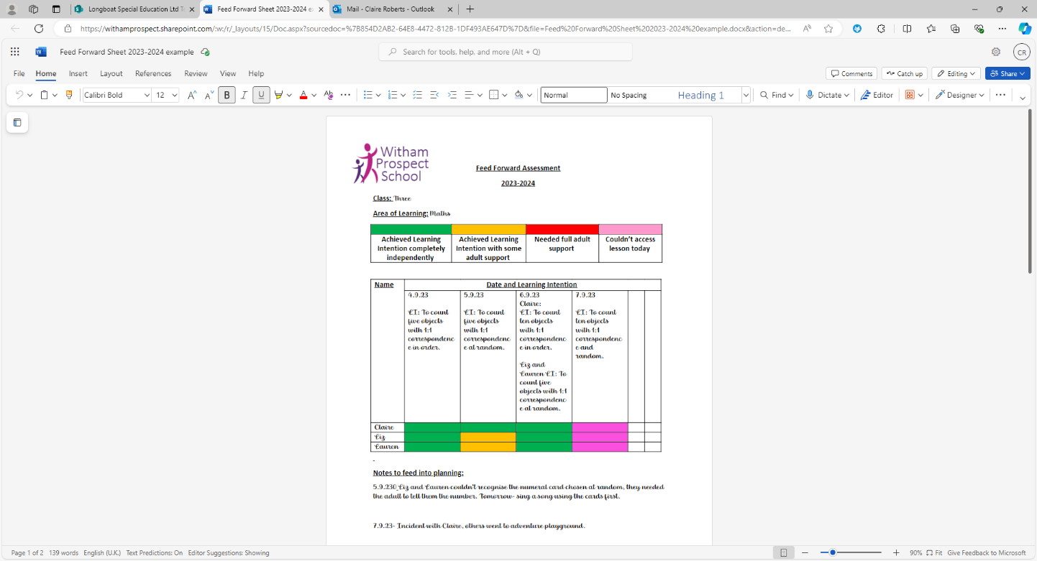

Daily work and evidence is then entered into a learning journey. Each pupil has a book for each of our core principles. Marking work with written comments isn’t effective for our pupils, instead we record using the overall learning intention, followed by a key takeaway. These key takeaways are measurable outcomes for each lesson, to measure the broken down progress.
We also record ‘wow moments’ in learning journeys to celebrate key achievements in any of the core principles. These learning journeys can then be shared with parents and outside agencies throughout the year.

Summative Assessment
Our children and young people all have an EHCP, many also have a PEP. There are key summative points in the year, whereby these outcomes are evaluated and reviewed. For the EHCP, a robust annual review process is in place, led by our SENDCo. Those pupils in care of the local authority then have a PEP meeting three times a year, led by a Designated Teacher, who is the class teacher for that young person. During these assessments, the targets and outcomes we assess, and use are triangulated across therapy advice and academic assessments. We understand that our pupils could have an endless list of targets to work on, but we want to ensure the approach is consistent. We now even share these with the residential home, so that key workers have a target from education. Our young people and children’s IHEPS are reviewed termly and are always on the tables so that any person working with them, can see their main targets.
The document below is a useful visual to see how we assess and move the development and learning forward for our children and young people.
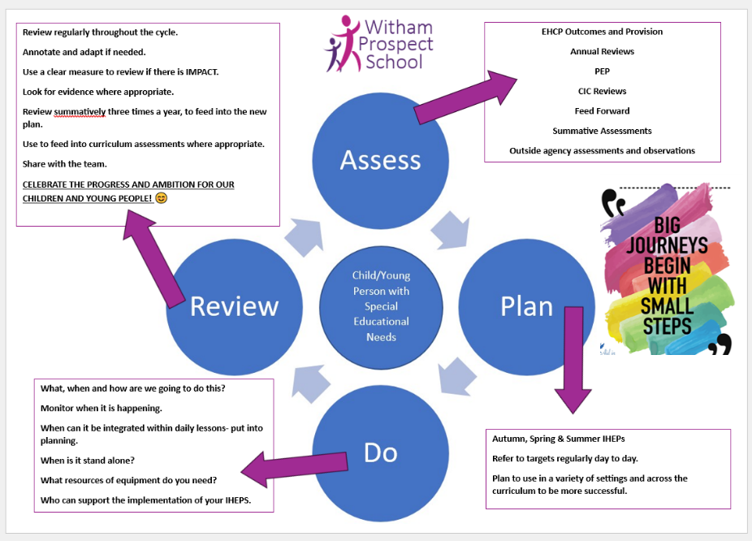

We then carry out termly assessments using the assessment descriptors below:

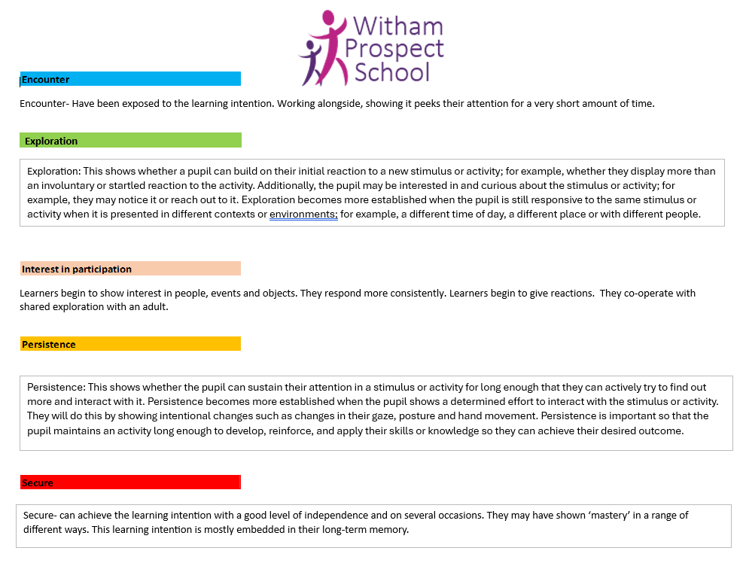
We assess the taught learning intentions against these descriptors to measure the progress of our pupils, term by term. Leaders analyse the data and create actions to support key areas for development across the curriculum.
As mentioned before, we value the expertise and input from the therapy team. We have regular assessments carried out, which forms a judgement of the progress our pupils are making. The list below isn’t exhaustive, but this demonstrates the importance of building a clear picture of the progress and outcomes we all strive for.
-Assistant Psychologist creates a termly behaviour newsletter which breaks down incidents and physical interventions, so that we measure the strategies we are using and adapt is necessary.
-Assistant Psychologist- carries out a BERRI assessment every three months. BERRI is a clinical evaluation tool for identifying, tracking and improving the outcomes of children with complex needs.
-Assistant Speech and Language Therapist, alongside our SALT- The CELF 4 Observation Scale is to showcase areas that our YP are improving in and highlight any areas that YP may require additional support with at school/residential.
The scale has been adapted to be more inclusive of our YP’s communication styles and include additional information regarding their social skills within residential and school settings.
-Occupational Therapist- regular assessments as on site, for example a sensory assessment is often carried out.
In addition to these assessments, we are then offered training and support on how best we can support our pupils SEND needs.

Keeping our Parents and Carers in the Loop
Our staff team send a weekly newsletter to our parents, carers and social workers. They also send an annual school report, highlighting achievements and next steps.

Accreditation
We have high aspirations for our children and young people and although they will not sit statutory assessments, alongside their peers across the local authority, we as a school, plan for them to leave with a portfolio of achievements.

